**BGMEA University of Fashion & Technology (BUFT)**

***Excellence through Education***



**Internship Report On**

**The Design Process of BEXIMCO Textile Ltd.**

***Yellow by BEXIMCO.***

***BEXIMCO INDUSTRIAL PARK***

***Sarabo, Kashimpur, Gazipur***

SUPERVISOR

**Afroza Akter Rita**

Assistant Professor

Department of Fashion Design & Technology

BGMEA University of Fashion & Technology (BUFT)

SUBMITTED BY

**Israt Jahan Anonya**

ID: 192-019-501

Department of FDT

A Report on Industrial Training submitted to the Department of

Fashion Design & Technology of BUFT in partial fulfillment of the requirements for

the degree of Bachelor of Science in Fashion Design & Technology at BUFT.

**24th September, 2023**

**INTERNSHIP REPORT**

**ON**

**The Design Process of BEXIMCO Textile Ltd.**

SUPERVISOR

**Afroza Akter Rita**

Assistant Professor

Department of Fashion Design & Technology

BGMEA University of Fashion & Technology (BUFT)

SUBMITTED BY

**Israt Jahan Anonya**

ID: 192-019-501

Department of FDT

**Exam Committee:**

Examiner 1 (Supervisor): ……………………………………………... Signature:

Examiner 2 (External Member): ……………………………………… Signature:

Examiner 3 (External Member): ...……………………………………. Signature:

**24th September, 2023**

**DECLARATION**

I am Israt Jahan Anonya, currently studying BSc. in Fashion Design & Technology department from batch 192, ID: 192-019-501 at BGMEA University of Fashion & Technology (BUFT) has hereby declared that the internship report is a work done under the supervisor **Afroza Akter Rita,** Assistant Professor of the Department of FDT.

Herewith I assure that that I have done industrial internship in Delicate Garments LTD,

Industrial Supervisor:

Herewith I assure that that I have done industrial internship in Delicate Garments LTD,

Industrial Supervisor:

Herewith I assure that I have done industrial internship in ***Yellow by BEXIMCO, BEXIMCO INDUSTRIAL PARK,*** Industrial Supervisor: MD. Alauddin, Asst. Manager, Yellow (Design).

SUPERVISED BY

**Afroza Akter Rita**

Assistant Professor

Department of Fashion Design & Technology

BGMEA University of Fashion & Technology (BUFT)

SUBMITTED BY

**Israt Jahan Anonya**

ID: 192-019-501

Department of FDT

----------------------------------

**Signature of Student**

**LETTER OF TRANSMITTAL**

Afroza Akter Rita

Assistant Professor

Department of Fashion Design & Technology

BGMEA University of Fashion & Technology (BUFT)

Subject: The Design Process of BEXIMCO Textile Ltd.

Dear Madam,

With great pleasure, here I submit my internship report on **“****The Design Process of BEXIMCO Textile Ltd”** that you have approved & assigned as a compulsory requirement of internship course. I have tried my level best to bring out the original scenario of BEXIMCO with full of effectiveness & efficiency.

I have really learned a lot and have gained valuable experience and knowledge while collecting information for the report. It was certainly a great opportunity for me to work on this real-life project to actualize my theoretical knowledge of this course in the practical arena and some more which is out of this course.

I hope that this project paper has been to your expectation, if you come across any question or quarries regarding these cases, it will be my pleasure to clarify your questions.

Sincerely,

Israt Jahan Anonya

ID: 192-019-501

Department of FDT

**ACKNOWLEDGEMENT**

A warm felicitation goes for me to acknowledge the people, who hold the desirability for encouraging, praising, assisting as well as believing me on the tasks of Merchandising activities what I have worked through my internship period. At First, I would like to take the opportunity to thank my internship supervisor Afroza Akter Rita, Assistant Professor at Department of Fashion Design & Technology, BGMEA University of Fashion & Technology (BUFT) for providing me guidelines, help in assisting my report. She was constantly supporting me with his inspiring personality. I will always be always thankful for his extraordinary reinforcement.

I would like to take the opportunity to thank MD. Alauddin, Asst. Manager, Yellow (Design) for being my on-site supervisor & providing me time to time information, suggestion as well as procedures to work with my topic.

Finally, I will show my gratitude to all the Management & Non-Management Staffs who have helped me during the internship period and the entire persons who somehow have impact on me in completing my whole report.

**CERTIFICATE OF COMPLETION FROM THE EMPLOYER**

**EXECUTIVE SUMMARY**

BEXIMCO is one of the largest groups in Bangladesh and highest GDP contributor. Here this is a great chance for me to do my internship in one of its concern organization YELLOW.

This is a large retail stores and has factory with all the facilities to composite yarn. Here the production process runs from making yarn to fabrics and from fabrics to finished garments. In this era of globalization, Yellow wants to go global too. Bangladesh is flourished with RMG sector where this division has its immense contribution as a large textile industry BEXIMCO has large numbers of employees but the productivity is getting slow day by day. So, it is a matter of concern that why this huge industry is doing stagnant profit. In order to grab more customers, there comes the retail store of Yellow Fashion Clothing.

I was selected for the Yellow, as a designer and this team is really supportive no matter where or whenever I got stuck. I have gained valuable knowledge and experience in the field. Yellow is full with new styles and different designs which push merchandisers to face huge stress and deal with lots of challenges from the changing of customer taste to predicting market demands to planning the product.

In this report, I have discussed what kind of activities I have done in details. From different aspects I designed various products. I have also tried to analyze the benefits of these services as well as my learning from the organization. From my personal view the learning aspect was fruitful and the experience there will help me in the future.

**TABLE OF CONTENTS**

**Chapter 1 – Introduction to Internship**

* 1. Objectives
  2. Methodology
  3. Scopes
  4. Limitations

**Chapter 2 – Overview of the Company**

2.1 Introduction

2.2 History

2.3 Key Officials

2.4 Departments of BEXIMCO

2.5 Products of BEXIMCO

2.6 About Yellow (BEXIMCO)

2.7 Mission

**Chapter 3 – Design Section of Yellow**

3.1 Yellow design Studio

3.2 Design Studio Mission

3.3 Activities, Products & Product Classification

3.4 Operation of Yellow Manufacturing

3.5 Design Process

3.6 Yellow Fabric Store

3.7 Cad & Pattern Section

3.8 Cutting & Sewing Section

3.9 Printing Section

3.10 Embroidery Section

3.11 Washing Section

3.12 Finishing Section

**Chapter 4 - Internship Experience**

4.1 Interview Session

4.2 Position, Duties & Responsibilities

4.3 Work Samples During Internship

4.4 Overall Analysis of Internship

**Chapter 5 -** **Recommendation & Conclusion**

5.1 Recommendation

5.2 Conclusion

* List of Abbreviations
* References

**CHAPTER 1**

**Introduction to Internship**

An internship report is a document that summarizes the experience as an intern at a company or organization. For compete my graduation, I must be submitted an internship or project reports. From those I prefer internship and done my Internship from Yellow by Beximco, Beximco Industrial Park. I was doing internship because through internship, I can learn lots of things. Those are –

* Intern position gets an extraordinary occasion to apply the information from the homeroom to certifiable experience.
* This work experience will help me of enriching my technical, Interpersonal and transferable skills while I gain details insight into the dynamics of a particular business sector.
* Internship assists me with learning about working environment culture, worker relations, and administration structure, cooperation which can help me locally available in my first expert work without lifting a finger than if I haven't had the proficient experience.

**Objectives**

Through the report I explain what I learn in my internship period. To make this report I recall all those skills and experience which I gain through internship. I analyzed lots of things about textile industry, and gain knowledge about it.

**Scopes**

Scope means how many uses for completing this report space. The scopes are –

* Company / Industry
* Discussion
* Internet
* Some of our senior brothers and sisters can help us.
* I can collect information various books and relevant paper what related with apparel

I am lucky enough that get a chance to know about the designing process. I get a clear idea how they operate the section and how to fulfill customer desire.

**Limitations**

Limitation refers the obstacles I have to face for completing this report and what I could not

cover for this limitation.

* Four months intern period is small time to know about Yellow Baximco.
* Short time visit in different work stations.
* Lack of instruction book, and any change.
* all personnel are always busy and work under extreme pressure for their nature of job and huge volume of the business.
* some of the information was confidential so I couldn’t able to gather those.
* Some of the focuses in various part are not describe as these are not accessible.

**CHAPTER 2**

**Overview of the Company**

The Ready-made Garment or RMG industry, which started its journey four decades ago, is now the powerhouse of Bangladesh's economy. Readymade garments (RMG) sector of Bangladesh has raised as the biggest earner of foreign currency. At present, the industry consists of over four thousand factories. Beximco Apparels Limited (BAL) a member of Beximco Group started its commercial production in March 1985 under the name of Comtrade Apparels Limited as a joint venture project between Comtrade Limited of Lausanne, Switzerland and Beximco Group. Beximco Apparels Limited is managed by a group of professionals, aims at producing high quality garments through an effective quality control system right from sourcing of fabric to end product. The company employed 876 employees as of February 01, 2009.

**Introduction**

BEXIMCO Group is one of the largest private sector industrial conglomerates in Bangladesh engaged in diverse business areas. BEXIMCO comprises of five publicly listed companies and sixteen private companies. Where, pharmaceuticals and textile section are the biggest one. BEXIMCO covers one of South Asia‟s largest vertically integrated textile and garment companies. The Textile division is a fully integrated manufacturer of cotton and polyester blended garments for men, women and children, both for domestic and export markets. BEXIMCO is also the largest exporter of pharmaceuticals in Bangladesh with a presence in 45 countries. The Pharmaceuticals division manufactures and sells generic pharmaceutical formulation products, active pharmaceutical ingredients (API) and intravenous (IV) fluids. The Group is also the largest ceramics exporter and has an investment in GMG Airlines, the largest private commercial airline in Bangladesh and in Unique Hotels & Resorts, which owns the Westin Hotel in Bangladesh.



**Corporate logo**

Bangladesh Export Import Company (BEXIMCO) maintains this logo from the initial stage of its business. They have a mission of taking Bangladesh to the world. So, with this logo “BEXIMCO” has taken its identity towards the people of the world. Yellow is textile section’s brand name of Beximco. Yellow launched in 2004, aims to bring world class fashion, quality & service at a justifiable price.

**History**

Since independence Bangladesh has come a long way, and the BEXIMCO Group of Companies is honored to have had a role in the development of its parent nation. The Group has worked with a simple philosophy; identify an important need and then do everything possible to successfully satiate that need, in a manner which best facilitates the well-being of the nation. As a result, BEXIMCO has focused on those industries which give Bangladesh a competitive advantage in the global market place in many cases creating the industries for the first time in the region. Throughout its four and a half-decade journey the Group has been one of the leading innovators in the country. Presently BEXIMCO Group comprises twenty-one companies. Today the BEXIMCO Group is the largest private sector group in Bangladesh. BEXIMCO was founded in the 1970‘s by two brothers – Ahmed Sohail Fasiur Rahman and Ahmed Salman Fazlur Rahman. Since the early days, the Group has evolved from being primarily a commodities trading company to a leading, diversified group with a presence in industry sectors that account for nearly 75% of Bangladesh’s GDP. BEXIMCO’s corporate mission is ―Taking Bangladesh to the world.

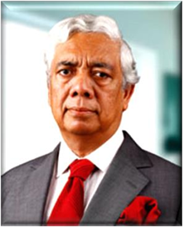

Mr. Ahmed Sohail Fasiur Rahman

Chairman & Managing Director

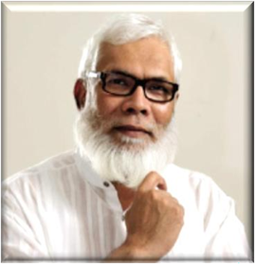

Ahmed Salman Fazlur Rahman

Vice Chairman

The group's key businesses include ceramics, pharmaceuticals, textiles, jute, information technology, aviation, media, finance, real estate, construction and energy. Its major industries are located at the Beximco Industrial Park in Gazipur, outside Dhaka. The group is listed on the Dhaka Stock Exchange and the Chittagong Stock Exchange, with a market capitalization of over US$ 2 billion. Its pharmaceutical division, Beximco Pharma, is listed on the London Stock Exchange. BEXIMCO is well positioned to capitalize on strong growth across industries in both the domestic and global markets. Each Group company is managed by an independent, professional team with significant depth of experience. Management teams have established a clear strategic plan that will further strengthen the overall platform. BEXIMCO intends to leverage its market position and global scale, further diversify operations into highly profitable sectors, capitalize on the domestic growth opportunity and selectively pursue international opportunities going forward.

In recognition of its corporate success and creation of shareholder value, the BEXIMCO Group has and continues to make significant contributions to Bangladesh’s society. Sponsored organizations include -- Proyash, a specialized institute that works for the holistic development of children with special educational needs and -- Gono Sahajjo-Songstha, an institution that provides education for the underprivileged. BEXIMCO was also an official sponsor of the Bangladesh National Cricket team for the ICC Cricket World Cup 2011 and also the official title sponsor of the FIFA friendly match between Argentina and Nigeria held in September, 2011.

**Key Officials**

❖ A. S. F. Rahman, Chairman

❖ Salman Rahaman Vice-Chairman

❖ Iqbal Ahmed, Group Director

❖ ABS Rahman, Group Director

❖ O K Chowdhury, Group Director and CEO (Power & Engineering)

❖ Nazmul Hasan Papon, Group Director and CEO (Pharmaceuticals)

❖ Syed Naved Hussain, Group Director and CEO (Textiles)

❖ Sami Wadood, CEO (IT & Telecom)

❖ Humayun Kabir FCA, CEO (Ceramics)

❖ Sumantra Dutta (Sumo), CEO (Satellite TV/DTH)

❖ M Shamsur Rahman, CEO (Media)

❖ Shah A Sarwar, Managing Director and CEO (IFIC Bank)

❖ M Asad Ullah FCS, Executive Director & Company Secretary

**Departments of BEXIMCO**

* Production planning & control
* Yarn
* Weaving
* Knitting
* Batch preparation
* Dyeing
* Finishing
* Lab & Quality assurance
* Garments (woven & knit fabrics)
* Denim
* Washing plant
* Section wise research & development
* Maintenance
* Utility
* Supporting department:
* Personal administration
* Marketing
* HRD
* Finance & accounting
* IT

**About Yellow (BEXIMCO)**

Yellow is a Bangladesh-based fashion brand and clothing retailer owned by Beximco.[1] Its corporate headquarters is located at Beximco Industrial Park, Dhaka, Bangladesh. YELLOW, the trendiest fashion brand from Bangladesh, is mostly distinguished for its true international quality designs and fabrics. As a retailer of the parent brand BEXIMCO, it started its journey in 2004 and now has 19 stores are across Bangladesh and Pakistan and a 24/7 online store. Since its origin, it has been offering world-class designs at an amazing value price. The product line includes a wide range of fashion clothing, fragrance, and accessories for men, women and children, textiles for home decoration, avant-garde ceramic items, paintings, books and many more. “YELLOW is spreading out in quite a big way. Starting as a clothing line, it has now developed into a lifestyle brand. It recently opened another flagship store of YELLOW in Gulshan, Dhaka. YELLOW store in Dhaka’s Dhanmondi is the biggest in the country so far. It’s a lifestyle shop that covers all the segments including men, women, children and home textiles, to cater to all economic sections of the society. “In Bangladesh, YELLOW by far, is the number one brand. It is now partnering with Amazon Global to take the brand to global consumers. Very soon customers will find YELLOW Ethnics in India as well. Yellow has a design studio in Karachi with 35 designers including one from Mango to come up with innovative and original creations. In the future, it might also tie up with Indian retailers to make this brand in-store format as well. The meaning of yellow to Pakistan people is happiness, wisdom, imagination and shrewd personality. The meaning of yellow to Pakistan people is happiness, wisdom, imagination and shrewd personality. Yellow is a design driven brand and celebrates creative and original thinking to highlight lighthearted and optimistic view of life through superior quality product. Their style captures a modern interpretation of fashion and their relax attitude expresses a comfortable and a confident quality.

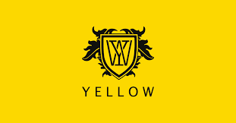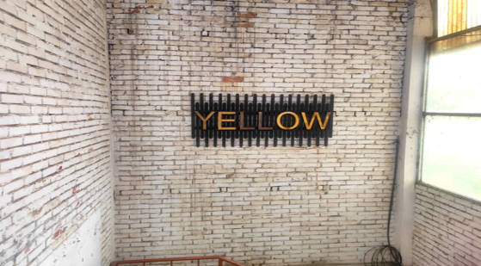

**Mission**

Each of their activities must benefit & add value to the common wealth of their society. They firmly believe that, in the final analysis they are accountable to each of the constituents with whom they interact; namely; their employees; their valued customers, their suppliers, their business associates, their shareholders & their fellow citizens. The Group is present in retail apparel through ―Yellow, a youthful brand sold through BEXIMCO owned outlets. Yellow is a design driven brand that celebrates creative and original thinking to highlight a lighthearted and optimistic view of life through a superior quality product. Yellow captures a modern interpretation of fashion and relaxed attitude expresses a comfortable and confident quality. The adventurous spirit of the line is built from BEXIMCO Group's heritage in innovation and living a life full of passion that is open to discovery. Yellow is inspired by its customers; Unconventional yet high-quality.

**CHAPTER 3**

**Design Section of Yellow**

The design department can be considered as the research and development department of a clothing factory, because it is in this department that the prototypes of garments are developed and prepared for selling and production. Textile design is a significant section of the textile manufacturing procedure. Textile design is a highly creative field that involves the process of creating the designs that are printed on these woven, knitted, or other types of fabrics. The field of textile design includes pattern-making, while also managing the production process. Yellow designers of design section are highly-creative people who can draw, have a superior eye for color, pattern, and texture, and an appreciation for the fine points of textiles and fashion. They recognize the fluctuations in trends and fashion, understand textile techniques, are good communicators, possess problem-solving skills, and enjoy a challenge, all while staying on budget and deadline.

**Yellow design Studio**

Yellow is a design driven brand that celebrates creative and original thinking to highlight a lighthearted and optimistic view of life through a superior quality product. The name YELLOW, itself has now become a distinct clothing brand in Bangladesh and the credit goes to its exclusive collection and comfortable products. Yellow's very own Design Studio brings forward sensational designs and collections that inspire. The works in the BEXIMCO Yellow Design Studio are done keeping eco-innovation in mind, so as to contribute to sustainable development while creating designs that people love.

In designing section of yellow every design is done in a systematic way. There are three co head designers under one head designer and the co-head designer are divided into three categories such as men, women and kid. There are also have senior executive, executive, junior executive, who are work under co-head designers. Yellow brand always designs their product according to target seasons. There are four main seasons – spring, summer, fall, winter and there are extra season – Eid-Ul-Fitor, Eid-Ul-Adha, Pohela Boishakh for their production.

**Design Studio Mission**

To provide design and product development support from fiber to garments to leading retailers and brands using integrated manufacturing resources, powerful CAD tools, technology collaboration with major suppliers (like CIBA, DuPont etc.) and interface with fashion forward customers, rapidly develop and bring trendy, innovative differentiated products to our strategic partners every season. The Design Studio works to produce entire collections with Inditex including women’s and men’s clothing, woven and knit tops, casual and denim bottoms and jackets. They have now introduced a catalogue which will highlight our concept of completes new looks, products and fabric swatches and we will be sending one of these to all our key customers almost every eight weeks.

**Activities, Products & Product Classification**

* **The Yellow Man**

A confident, intelligent and successful individual who believes in making his own destiny. Personality can be reflected through clothing. From office mornings to an evening with friends, Yellow answers the need for individuality, quality and style by providing superior, fashion forward products.

* Panjabi
* Fatua
* T-shirt
* Shirt
* Coat
* Waist Coat
* Shoes
* Wallet
* Tie
* Undergarment
* **The Yellow Woman**

A stylish, intelligent and confident soul who enjoys her success, juggle among home, work and social circle. The wardrobe that compliments modern lifestyle. Yellow products are inspired by young, confident and successful.

* Salowar-Kameez
* T-shirt
* Shirt
* Tops
* Skirt
* Bullero
* Pant
* **The Yellow Kid**

Yellow kid is a child of a successful couple who is inspired by the success and style of his parents. He has a sense of style and a desire to stand out among his peers. Yellow steps in, by providing clothing and accessories for the kids, which are an annex of the parents’ personality.

**Boys**

* Panjabee
* Fatua
* T-shirt
* Shirt

**Girls**

* Salowar-Kameez
* Frock
* Dress
* Tops
* Skirt

**Operation of Yellow Manufacturing**

The readymade garment manufacturing processing depends on some steps and techniques. The clothing creation running actions and methods included in the developing outfits for the huge of creation in company time frame for company reasons is known as outfits developing technologies.

|  |  |  |  |
| --- | --- | --- | --- |
| **SL No** | **Operation** | **Job** | **Method** |
| 01 | Design/Sketch | It is given by buyers to manufacturers containing sketches including measurements of particular styles. | Manual/Computerized |
| 02 | Basic Block | Basic block is an individual component of garments without any style of design (without Allowance, Style, Design) | Manual/Computerized |
| 03 | Working Pattern | When a pattern is made for a particular style with net dimension regarding the basic block along with allowance then it is called working pattern. | Manual/Computerized |
| 04 | Sample Garments | To make a sample, this will be approved by buyer. After making a sample, it is sent to buyer for approval to rectify the faults. | Manual |
| 05 | Approved Sample | After rectify the faults, sample is again sent to buyers. If it is ok then, then it is called approved sample. | Manual |
| 06 | Costing | Fabric Costing, Making Charged, Trimmings, Profit. | Manual |
| 07 | Production Pattern | Making allowance with net dimension for bulk production. | Manual/Computerized |
| 08 | Grading | If the buyer requires different sizes, so should be grade as S, M, L, XL, XXL. | Manual/Computerized |
| 09 | Marker Making | Marker is a thin paper which contains all the components for different sizes for a particular style of garments. | Manual/Computerized |
| 10 | Fabric Spreading | To spread the fabrics on table properly for cutting. | Manual/Computerized |
| 11 | Cutting | To cut fabric according to marker dimension. | Manual/Computerized |
| 12 | Sorting & Bundling | Sort out the fabric according to size and for each size make in individual bundles. | Manual |
| 13 | Sewing | To assemble a full garment. | Manual |
| 14 | Ironing & Finishing | After sewing we will get a complete garment which is treated with steam ironing & also several finishing processes are done for example extra loose thread cutting. | Manual |
| 15 | Inspection | Should be approved as initial sample. | Manual |
| 16 | Packing | Treated by Polyethylene bag. | Manual |
| 17 | Cartooning | After packing, it should be placed in cartooning for export. | Manual |
| 18 | Despatching | Ready for export | Manual |

**Design Process**

The design process is a method you use to be more creative, productive, and accurate. It is a series of activities carried out by a designer, which may include the use of design methods.

**Working Procedure of Design Process:**

Design Process

Research (Current Trend)

Color, Silhouette

Mood Board

Color Board

Fabric Plan

Sketch Planning (DD)

Making Pattern & Sampling Plan

Surface Ornamentation (If needed)

Check the Fit and make the

Styling

Hand over to merchant and follow up

Production

Plan for marketing (If something new)

**Yellow Fabric Store**

Fabric stores specialize in the sale of fabric along with sewing notions and patterns. Fabric store in a garment factory plays a vital role in garment manufacturing process, by not only offering the factory a storage space for its raw material inventory, it also serves as fabric inspection station. Like design studio Yellow has its own fabric store. This department's main responsibility is to store all the raw materials needed to make the garments. This division work with many different types of fabrics. For the sample making as well for bulk production they are produced fabric for Beximco Group according to the requirement of the buyer. Actually, they take some order from different factories for produce the woven fabric. For the reference order to make easy to use the same fabric they use a specific code for the fabric. Actually, in this factory term it’s called DISPOSITION.

Like- Dispo No: ISL_SP_330353 or ISL_SHU_15445

**Working Procedure of Fabric Store Department:**

Fabric receiving

Fabric dispatched from supplier

Fabric checking

Send to the merchandiser for approval

Shade checking

Fabric checking by security guards

Kept in store

Fabric lot rejection

Quality checking for defects

Here, I tried to show an overall work procedure of Yellow Fabric Store. Everyday here works lots of employee to make sure that the next processes such as [**spreading**](https://garmentsmerchandising.com/10-requirements-of-fabric-spreading/), designing cutting, [sewing](https://garmentsmerchandising.com/list-of-sewing-machine-used-in-apparel-industry/)to get smooth [**production**](https://garmentsmerchandising.com/how-to-estimate-production-capacity-of-a-garment-factory/) don’t stop because of this section.

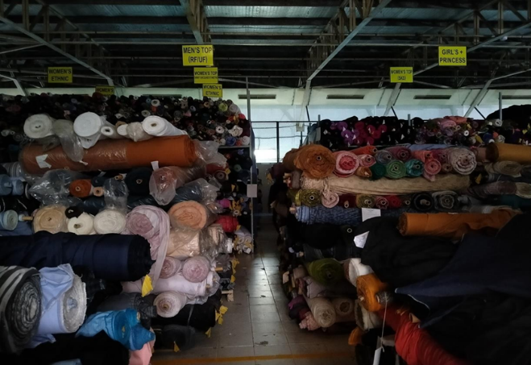

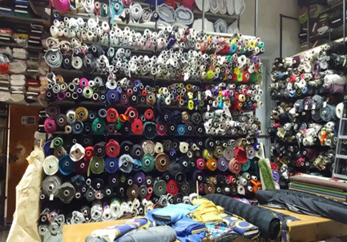

**Images of Yellow Fabric Store**

**Cad & Pattern** **Section**

Computer-aided design, commonly known as CAD, is a manufacturing process that allows us to digitally create 2D drawings or 3D models of future products. This CAD system is a combination of hardware & software that enables designer to design everything from apparel industry. It also supports the design process, helping create, modify, analyze, and enhance a design. CAD software came from LYCRA LECTRA TECHNOLOGY. Nowadays, it becomes one of the most essential tools for pattern making and related jobs in the clothing industry. It is used for pattern making,[**pattern grading**](https://textilelearner.net/garment-pattern-grading-techniques/), and the making of the marker. Using CAD software, a fashion designer can create new sketches, patterns, prints more quickly and precisely. With the increasing use of CAD, fashion designers can create multiple variations of a single design and style and adapt it to varying material and pattern. The major benefit of CAD software in the clothing manufacturing industry is the designers do not need to produce different swatches all the time for different colors as they can now see how a particular fabric or apparel looks in different shapes and colors on the computer screen itself. The total design can be easily personalized and customized within a short period of time without significant delays or cost increases. It brings a revolutionary change in today’s readymade apparel export business. But It’s very expensive software, so most of the garments and any other sector are not uses this so much. CAD operator has to train themselves according to the update of CAD software. Sometimes, it’s too tough to find a skilled operator to run CAD software. So, it’s quite problematic for small companies. CAD master are working in Cad section of Yellow. They are highly trained employers. To create new fabric sample swatches, print or embroidery motif & outfit designs cad master has to work regularly.

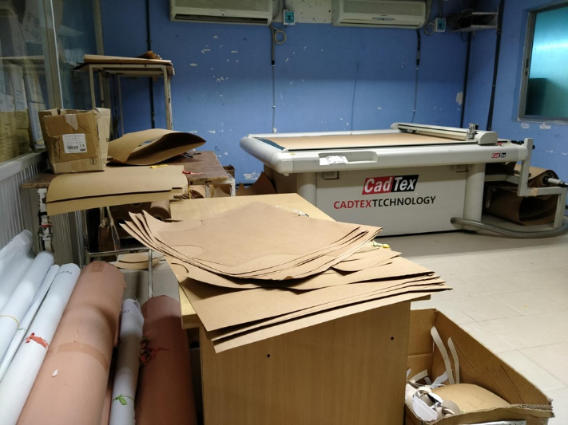

**Images of Cad & Pattern Section**

**Cutting & Sewing Section**

* **Cutting Section**

Cutting is one of the major processes in garments manufacturing. The cutting department is responsible for cutting fabrics for the garment orders and feeding the sewing department with cuttings. Firstly, the cutting department provides the pattern of garment to be cut by the production department. The various parts of the pattern are then spread to the appropriate location above the spread fabric by the cutting master. After this, all the parts of the pattern are removed by marking with chalk and all these layers are cut together by a cutting machine.

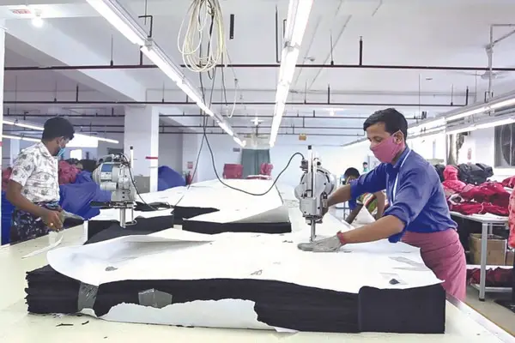

**Images of Cutting Section**

**Working Procedure of Fabric Cutting Section:**

Pattern received from pattern department

Cutting ratio received from the merchandiser

Marker making

Fabric received from the store

Fabric Checking

Numbering

Fabric Spreading

Marker placing on to the lay

Cutting the fabric

Checking

Sorting and Bundling

Send to the sewing department

* **Sewing Section**

Sewing means joining of different parts of garments with the use of needle and thread. Without needle and thread, we can also make garments by using alternative methods of joining like adhesive, welding etc. It is one of the basic steps of the apparel manufacturing process. The sewing section is the most important department of the garment manufacturing industry. The main purpose of sewing is to produce seam. The joining process “sewing” can be characterized on the basis of information about the sewing thread, the textile fabric, and the construction of the connection (thread/laying of textile fabric). A connection by sewing occurs by the linking or chaining of one or more [**sewing threads**](https://textilelearner.net/sewing-thread-consumption-formula/) with the textile fabric. The manner, position, and number of linking or interlacing points in the textile fabric describe the joint produced. This department converts fabric into cloth or garments through different sewing machines and different sewing processes. In this work place there are many operators who perform single operation. All this factor decides what parts of garment can be sewn at that station. To complete the perfect garment easily and timely Floor in-charge always maintains a working procedure.

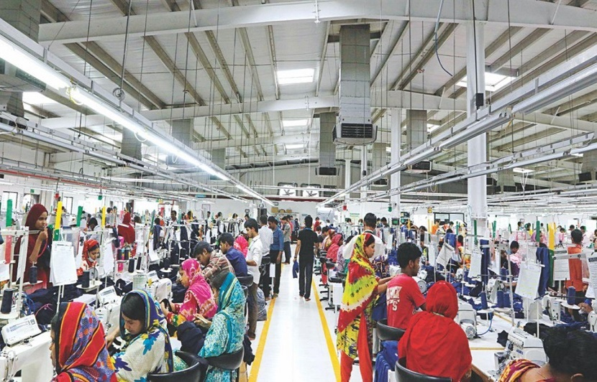

**Images of Sewing Section**

**Working Procedure of Fabric Sewing Section:**

Product analysis

Set up target for production

Set up machine layout on the basis of target

Set up operator layout on the basis of target

QC check of product

Line balancing

Line setup

Complete parts making individually

Online QC check

Cutting parts distribution to the operator and helper

Cutting parts received section

Distribution all the processes

Final quality check (for each Garment)

Counting output and checking with the target

Online quality audit

**Printing Section**

Printing has added a new dimension and diversity to the textile industry. The fabric is dyed, printed and finished before it is made. At present, the importance of printing is very high in the garment industry. Different types of designs are printed on any fabric which brings out the taste of the people. The world’s textile printing is also changing rapidly in line with human tastes. Customers are demanding a variety of color and design variations. Therefore, textile printing is constantly changing in response to their demands. Though printing is done in many advanced ways but the beginning of printing was not so advanced. The Chinese were the first to engrave on wooden blocks and started printing cloth. At that time only red and blue colors were used for printing. But at present about 12-15 colors are used in printing. In Yellow, this section work with a procedure where a specific pattern or design is created by applying color to the fabric. To put it more simply, this section initially works on decorating a fabric by applying different color patterns or designs on a finished product.

**Working Procedure of Printing Section:**

Printing

Printing Paste Formation

Fabric Preparation

After Treatment

Steaming & Curing

Drying

There are many types of printing. Those are –

* **Block Printing:** The block printing is an old method of printing which involves the use of wooden blocks with raised printing surface, which are inked and then pressed on to the fabric. This printing method is used only at small scale or in cottage industry and is not used at industrial scale because of less flexibility and productivity.

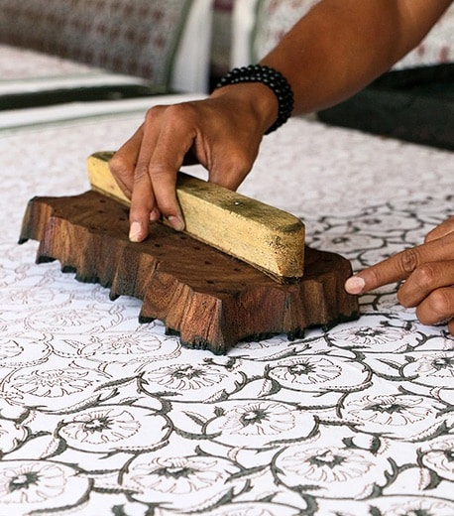

**Images of Block Printing**

* **All Over Printing:** All over printing is a special type of printing technology that allows a particular design to be repeated continuously throughout the entire surface of fabric or apparel. Any fabric can be printed by all over printing method (AOP).

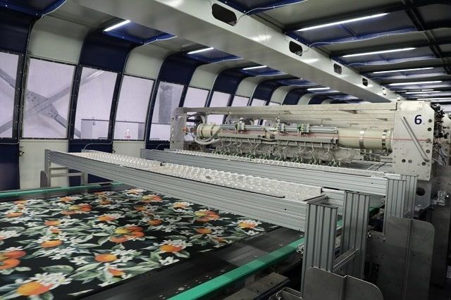

**Images of All Over Printing**

* **Flock Printing:** Flock printing is done by depositing various flocks on the surface of the fabric. Flocks mean small finely cut natural or synthetic fibers. Flock is made from natural or synthetic materials like cotton, rayon, nylon or polyester. It adds a velour, fluffy, velvety like texture and is a great way to enhance the feel, color and overall appearance of a garment. The process uses special equipment that electrically charges the flock particles causing them to stand-up. The fibres are then propelled and anchored into the adhesive at right angles to the substrate. The application is both durable and permanent.

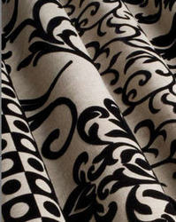

**Images of Flock Printing**

* **Glitter Printing:** Glitter printing enables the fabric to show glittering granules on the fabric. For this Glitter powder is used. Glitters add on the garment with paste and fixed by heat on a specific area.

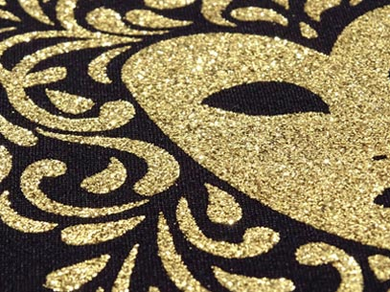

**Images of** **Glitter Printing**

* **Batik Printing:** Batik printing is a traditional textile printing technique that originated in Indonesia. The term “Batik” is an Indonesian-Malay word. A special type of resist-dyeing technique is used for Batik printing. Under this technique, parts of plain cloth are covered by wax and then the cloth is dyed. Batik is made either by drawing dots and lines of the resist with a spouted tool called a canting, or by printing the resist with a copper stamp called a cap.

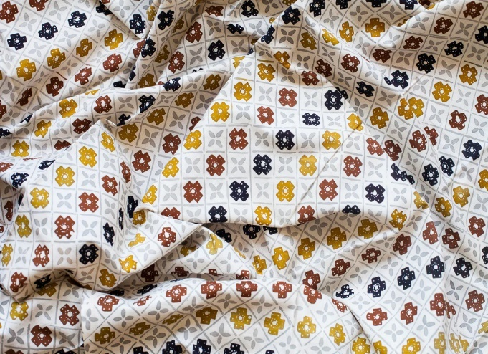

**Images of** **Batik Printing**

* **Sublimation Printing:** Sublimation printing is a technique that uses heat sensitive inks. These inks turn into gas under the influence of heat and combine with a 100% polyester medium. Since the ink becomes part of the structure of the material, the images on the fabric don't fade or crack – even after multiple washings. In simple terms, it's a method of printing that transfers a design into a material or fabric using ink and heat.

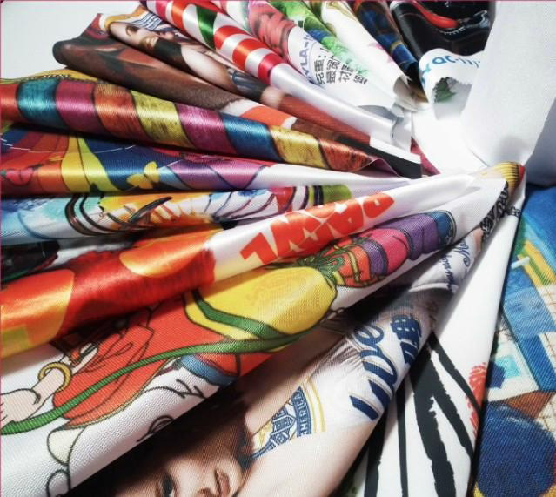

**Images of** **Sublimation Printing**

* **Foil Printing:** Foil printing is to print some pattern with the foil on the fabric for a shiny effect. It is a special kind of printing procedure where heat, pressure, and a foil are used to create glossy designs and graphics. Foil printing has various applications and is increasing in popularity as a method of printing in textile material like T-Shirts, Kurtas, and Upholstery etc.

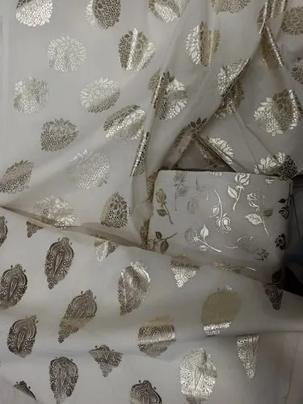

**Images of** **Foil Printing**

* **Rubber Printing:** Rubber printing is one of the important [printing](https://textilefashionstudy.com/textile-printing-definition-styles-and-methods-of-printing/) processes. It is an opaque base that rises up on being heat set to provide a raised print effect. It is also called the Foam Print or Emboss print for the raised print effect.

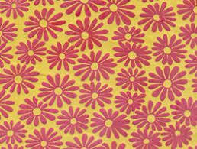

**Images of Rubber Printing**

* **Roller Printing:** The journey of roller printing began in the late seventeenth century. It  is invented by Thomas Bell of Scotland This method allows to print different color designs on any fabric at the same time. It is the machine method of printing designs on cloth by engraved rollers. It is a high-speed process capable of producing over 6000 yards of printed fabric per hour. Roller printing, also called direct printing. rubber, gelatine, leather, natural rubber, silicone rubber, neoprene, nitrile rubber, synthetic rubbers such as Hypalon or ethylene propylene diene rubber (EPDM) are used as roller printing materials.

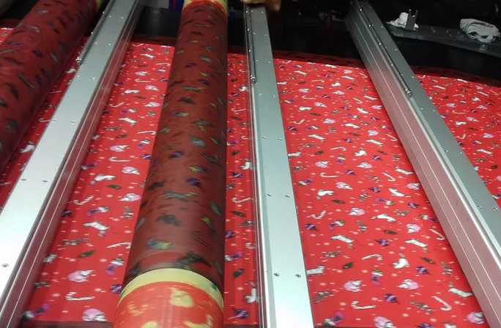

**Images of** **Roller Printing**

* **Screen Printing:** Screen printing was introduced in the late eighteenth century, a few years after roller printing. It is a printing technique where a mesh is used to transfer ink onto a substrate, except in areas made impermeable to the ink by a blocking stencil. A blade or squeegee is moved across the screen to fill the open mesh apertures with ink, and a reverse stroke then causes the screen to touch the substrate momentarily along a line of contact. This causes the ink to wet the substrate and be pulled out of the mesh apertures as the screen springs back after the blade has passed. One color is printed at a time, so several screens can be used to produce a multicolored image or design.

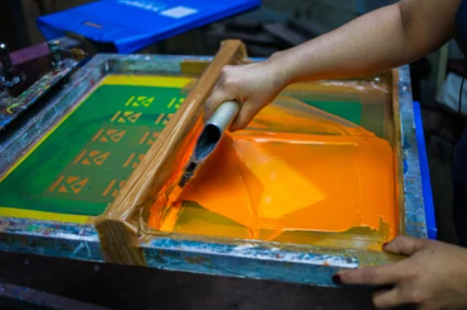

**Images of** **Screen Printing**

* **Transfer Printing:** In transfer printing, a design is printed first on a flexible non-textile substrate and later transferred from the paper to a textile substrate. It involves a number of processes in which designs are first usually printed onto paper. and then in latter and separate process transferred to a textile.  It is the advanced technique of printing where possibilities of faults are less as well as more accuracy can be achieved.

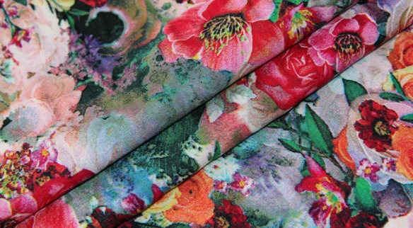

**Images of Transfer Printing**

* **Digital Printing:** This method can be used for most of the commercially available fabrics. In this method, a printing pattern can be directly printed from the computer onto the fabric with an ink-jet printer, without any need for making printing screens or engraved rollers. The design-to-print lead time is minimum in digital ink-jet printing and complex designs of photographic quality can be promptly printed.  This process allows for single pieces, mid to small-run cycle production and even long-runs as an alternative option to screen printed fabric. In digital printing, it is necessary to pre-treat the fabric.

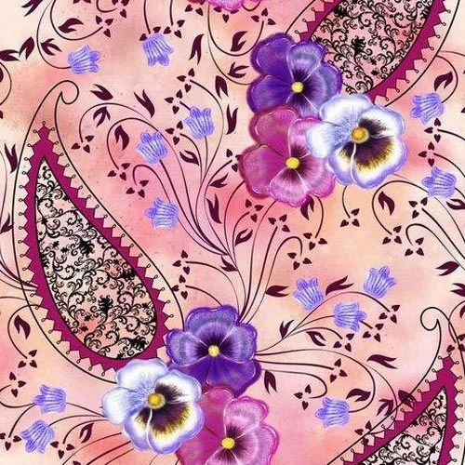

**Images of Digital Printing**

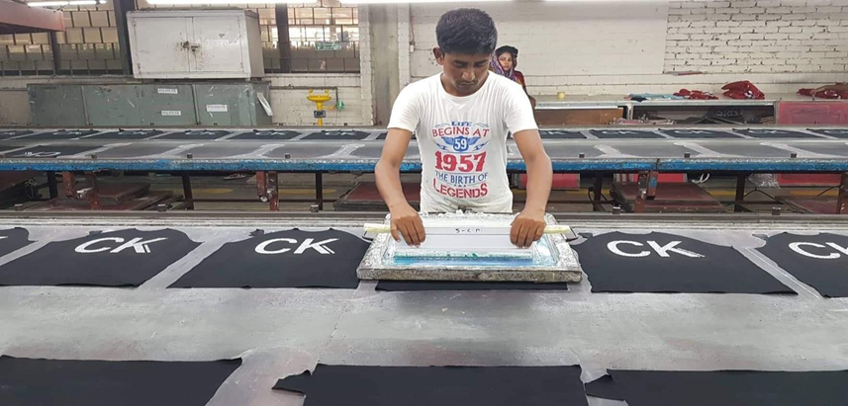

**Images of Printing Section**

**Embroidery Section**

Embroidery is the process of embellishing the surface of textiles with decorative stitching using colorful threads often made of silk or cotton. Embroidery is an old art form. It's been found on ancient textiles from China and Russia dating back thousands of years. One famous example of embroidery is the Bayeux Tapestry from circa 1076. This decorative work, almost 230 feet (yes, that's feet!) long, is a narrative scene of the Norman Conquest of England. It's created entirely of many kinds of embroidery stitches on linen cloth.

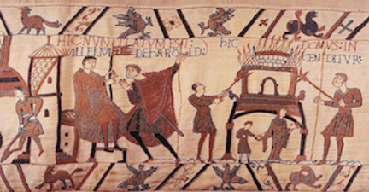

**Images of Bayeux Tapestry, a famous work done in embroidery**

Cultures all over the world have embroidery traditions. Throughout history, embroidery on textiles sometimes denoted status in society or wealth. Embroidery can be done by hand, but the machine is used for bulk production and a difficult pattern. It is done by using a sewing machine or embroidery machine to create beautiful patterns on textile. There is a process-specific process of machine embroidery on the fabric used in the garments industry. It is one of the special tasks which is done according to the buyer's requirements. In the past embroidery had done by using the manual method. But now a day, it is done by applying a computerized method. In Beximco by Yellow has their own embroidery section. From the sewing section or from the cutting section, the embroidery section receives the garments and then they start their embroidery process.

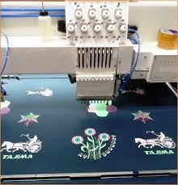

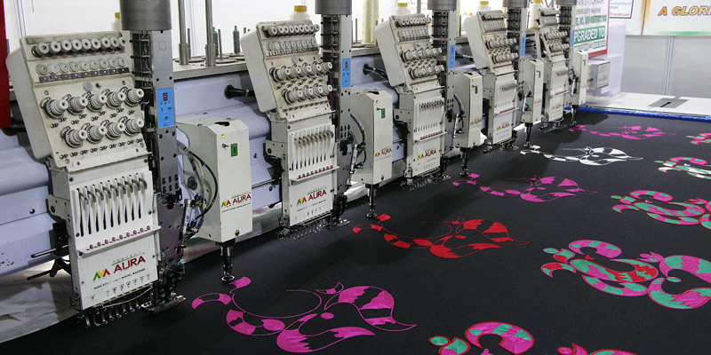

**Images of Embroidery Section**

There are many types of embroidery. Those are –

* **Surface Embroidery:** Surface embroidery is a type of embroidery whose pattern is a kind of decorative stitching and works with thread without fabric on canvas. Its varied forms, styles, different textures, dimensions, images, etc. are added to the canvas to create a variety of simple and complex designs. It has many forms also. Surface embroidery is a very available technique that does not require special fabrics or expensive threads but requires exploration and creativity.

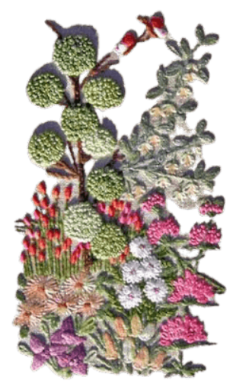

**Images of Surface Embroidery**

* **Counted Embroidery:** Counted thread embroidery is a type of embroidery that follows a precise and uniform pattern. There are different types of counted embroidery. In counted embroidery, the fabric threads are counted by the embroiderer before the needle is inserted into the fabrics.
* **Needlepoint Embroidery:** The idea of needlepoint embroidery, we get from the ancient Egyptians, who used this kind of stitching in their tent as a canvas. Silk, cotton, wool, different types of fiber, etc. are used for this type of sewing. There are different types of needlepoint canvas available in the market such as mono, interlock, plastic, Penelope, rug’ etc. and their sizes also vary. Currently, this sewing is spreading commercially. Some of the notable stitches used in needlepoint embroidery are brick stitch, Gobelin stitch, mosaic stitch, Parisian stitch, Smyrna stitch, tent stitch, etc.
* **Whitework Embroidery:** Different styles of whitework embroidery have evolved at different times, from different areas. The sewing and foundation fabric colors are the same in whitework embroidery. The term whitework refers to a variety of precise forms that refer to freestyle, counted thread, and canvas work techniques.

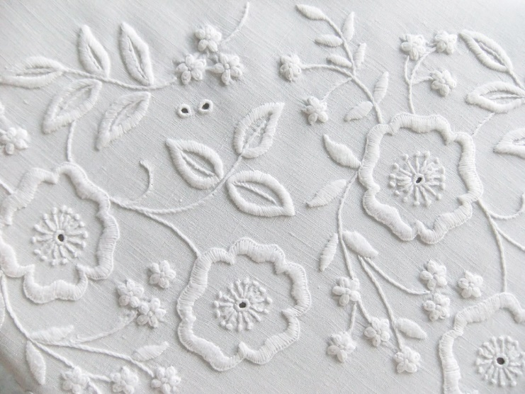

**Images of Whitework Embroidery**

* **Overlord Embroidery:** Overlord embroidery, a descriptive embroidery replica of the Bayeux tapestry created to commemorate the invasion of England from Normandy 900 years ago. It depicts the story of the D-Day landing on 6th June 1944 and the ensuing Battle of Normandy. The story revolves around 34 hand-stitched panels with a total length of 83 meters.
* **Black Work Embroidery:** Black work embroidery refers to the work of black yarn. Blackwork on silk yarn over linen was the most common household embroidery technique for household items such as shirts, sleeves, ruffles, caps and cushion covers during the reign of Elizabeth1.
* **Cross Stitch Embroidery:** Cross stitch embroidery is a popular type of stitching whose pattern looks like ‘X’. Linen, Aida, and mixed fabrics called ‘evenweave’ are used in cross-stitching. The reason for using ‘evenweave’ is that the term implies that the fabric woven contains the same number of yarns per inch. Cross stitch embroidery is very popular in the garments industry, used very commonly.

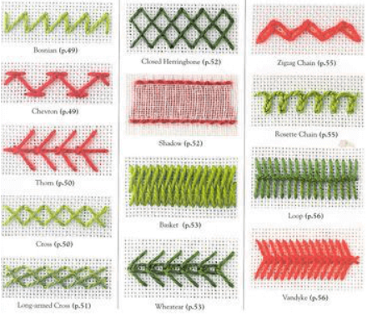

**Images of Cross Stitch Embroidery**

* **Sashiko Embroidery:** Sashiko is a traditional Japanese embroidery that is used to enhance the decorative beauty of clothing. The first embroidery was introduced in the Edo era to strengthen the old-fashioned homespun clothes.
* **Huckaback Embroidery**: Huckaback embroidery is a type of Swedish weaving. It is a simple embroidery and is embroidered using thread on huckaback fabric.
* **Eyelet Embroidery:** Eyelet embroidery was used to embellish and adorn a variety of projects from Christian gowns to denim jackets.

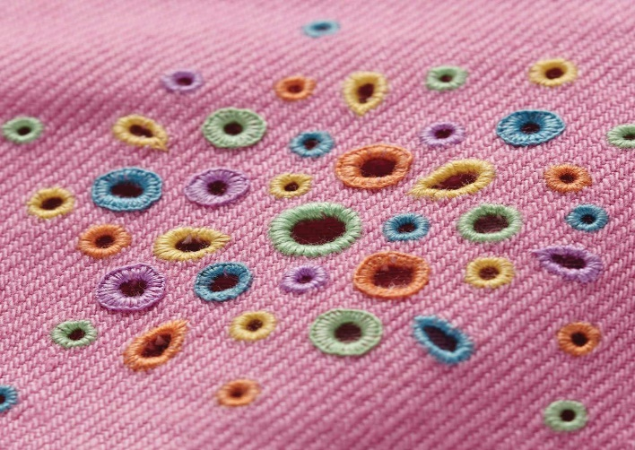

**Images of Eyelet Embroidery**

* **Redwork Embroidery:** Red work embroidery is a form of American embroidery that was especially popular in the 19th century for the use of red thread. As a result, they looked very attractive and were used to decorate household items.

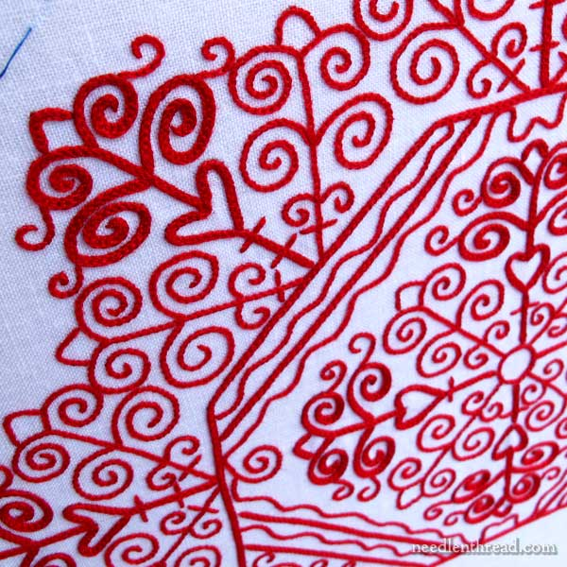

**Images of Red Work Embroidery**

* **Hardanger Embroidery**: Hardanger embroidery is a type of whitework embroidery whose origins are not well known. Hardanger embroidery is done with a thread color that matches the fabric. However, contemporary designs also use colorful, varied and overdone threads.
* **Blue Work Embroidery:** Blue work embroidery is almost like red work embroidery, the only difference is the color of thread. Instead of red thread, blue thread is used here. Different designs are usually embossed using blue thread on a white background. In the 1910s, blue work embroidery became very popular.
* **Drawn thread Embroidery:** Drawn thread is one of the oldest embroideries that was used throughout Europe. Its use can be seen in religious objects and various ornaments. A variety of designs were subtly painted on a white background.
* **Goldwork Embroidery:** Gold work embroidery is the art of embroidery using metallic threads. The term ‘goldwork’ is used because the threads imitate gold, silver, or copper. The same silver and old yarn were widely used in the most expensive tapestry, especially during the renaissance.
* **Hedebo Embroidery:** Hedebo embroidery originated in the Hedebo region of Denmark in the 1760s. At that time hedebo embroidery was used for towels, pillows, men’s shirts, women’s dresses, and farmer’s interiors.
* **Void Work Embroidery:** Void Work embroidery consists of a filled background. Its main component is clearly visible because everything around it ends up being tightly embroidered.

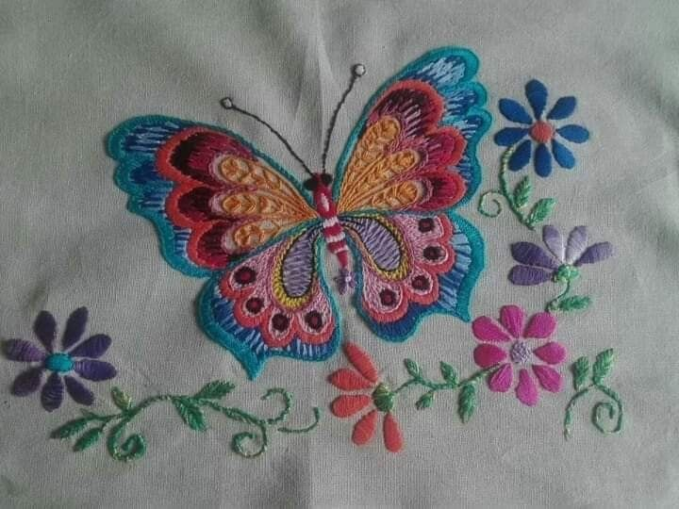

**Images of Void Work Embroidery**

**Working Procedure of Embroidery Section:**

Artwork from buyer

Input to ES-65(Software)

Design analysis

Send to buyer

Recommendation & correction from the buyer

Sample prepare

Send to buyer

If approved then for bulk production

**Washing Section**

Washing is a technology by which outlook, size, comfort, and fashion of garments or apparels are modified and given old garment effect is called garment washing. For the first time, the concept of garments washing technology was developed by Jack Spencer for the brand Lee. Stonewash was first developed by Francois Giraud and the sandblasting process was developed in 1988 by several branded companies in Italy. Indigo jeans were once the only item processed by the garment washing method, but this is no longer the case. A wide variety of different types of woven and knit fabrics dyed by different systems are now used in apparel that is garment washed before retail distribution. Emphasis is on comfort and softness. Also, some fashion trends favor the broken-in look and worn/faded seams that can only be achieved through garment processing. The sole purpose of garments washing is to –

* Remove sizing materials,
* Remove dirt, dust, rust, oil, stain etc,
* Bring old worn fashionable outlook
* Develop softness by removing hardness
* Create new color and tinted effect on garments.
* To meet buyers requirement.

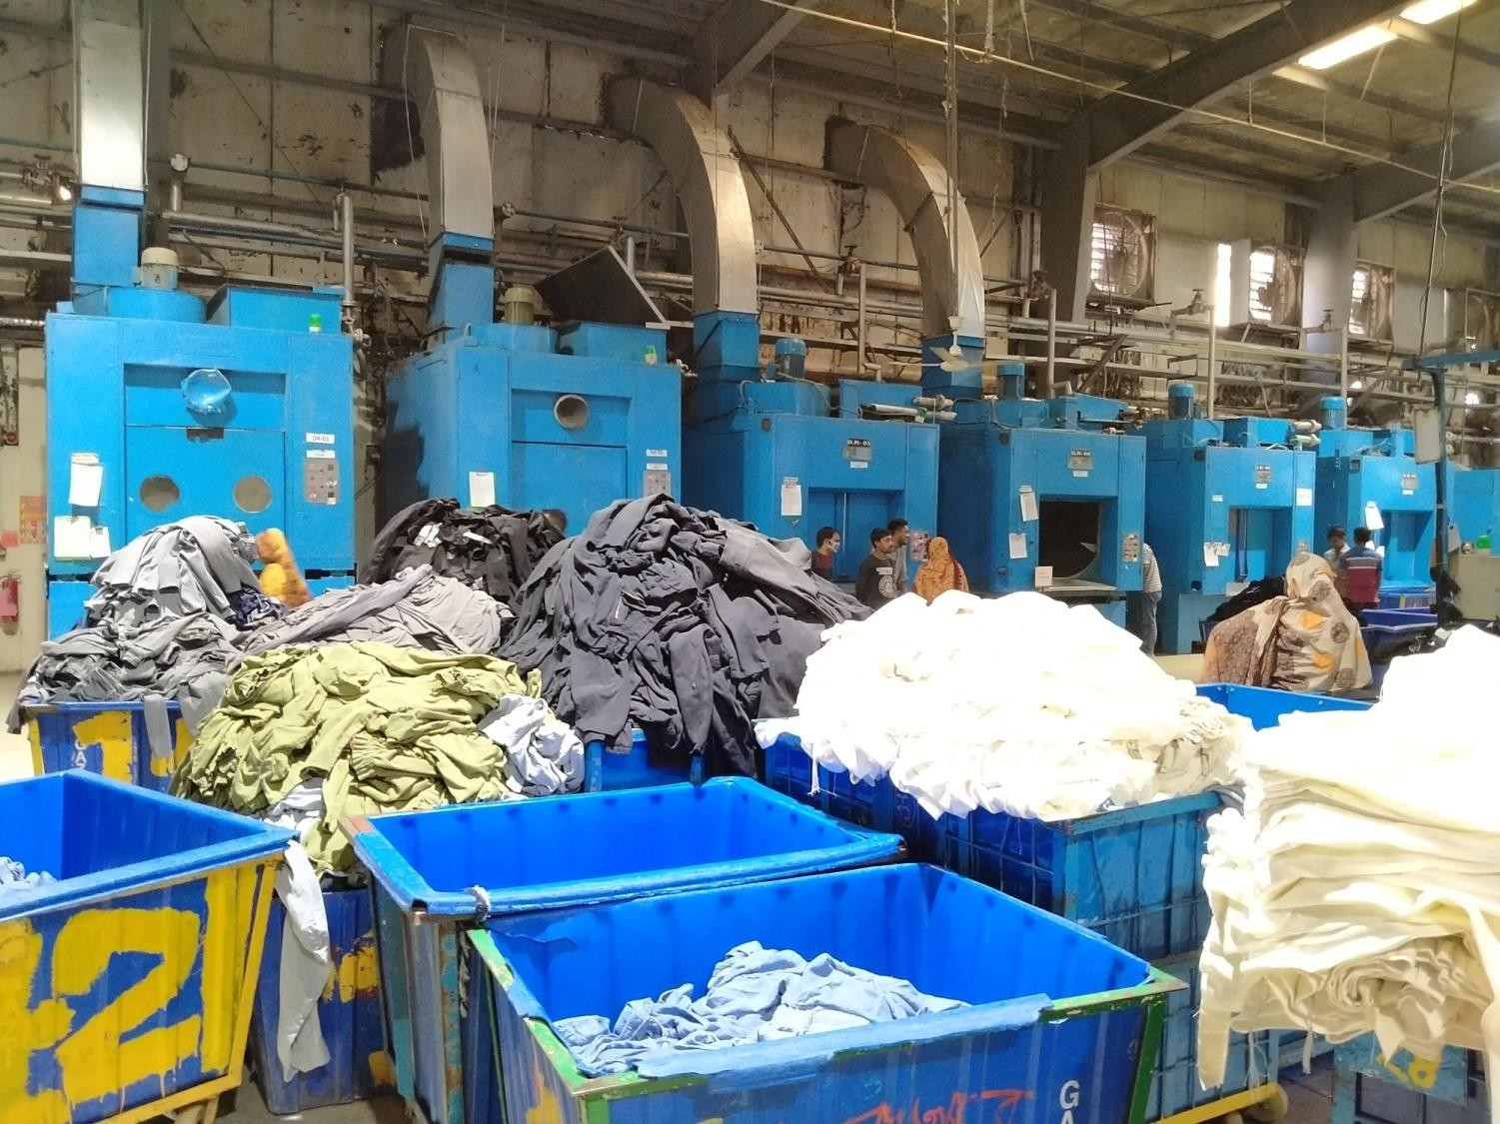

**Images of Washing Section**

Primary garment washing is classified into two types, these are-

1. Dry process or Mechanical process,
2. Wet process or chemical process.

* **Dry process or Mechanical process:** In this type of clothing wash, there are some processes which have done without using any chemical or without using any garment loading washing machine are called Dry process or Mechanical process. Sometimes the dry process can be done by using a mechanical method.

**Various types of dry processes applied in garments washing are mentioned below:**

* Sandblasting process,
* Hand sanding or Hand brushing process,
* Machine sanding process,
* Overall wrinkles process,
* Permanent wrinkle process,
* Grinding process,
* Destroy process,
* Tacking process,
* P.P spray process,
* Whiskering process,
* Curing process,
* Tearing process,
* Hand scrapping process.
* **Wet process or chemical process:** There are some processes in garment washing, which can be done by using chemical and garments loading [**washing machine**](https://garmentsmerchandising.com/types-of-machine-used-in-garments-washing-plant/) is called Wet process or chemical process.

**Different types of wet processes applied in garment washing are mentioned Below:**

* Normal wash or rinse wash,
* Silicon wash,
* Pigment wash,
* Caustic wash,
* [Bleach wash](https://textilelearner.net/bleach-wash-of-woven-denim/),
* [Enzyme wash](https://garmentsmerchandising.com/flow-chart-of-enzyme-washing-process/),
* Stone enzyme wash,
* Acid wash,
* Stonewash,
* Tie wash,
* Super whitewash,
* Tinting,
* Deep dyeing,
* Over dyeing.

**Finishing Section**

In the garment industry finishing section involves garment washing, checking, final inspection, pressing, packing, etc. A proper finishing process can improve the quality of garments and make on-time order shipments. Garments shipment is very much dependable on the Garments finishing section. The finishing section adds value to the product which attracts customers by the presenting activities of the product according to the buyer’s requirements. is the last stage of packed garments those are ready for sale. Therefore, it is one of the most important stage in whole garments [**manufacturing process**](http://textilemerchandising.com/category/production/)**.** Proper finishing process can be improved quality of garments and make on time order shipment. There are 3 major Functions of finishing section in garment industry.

* Checking
* Pressing
* Packing.

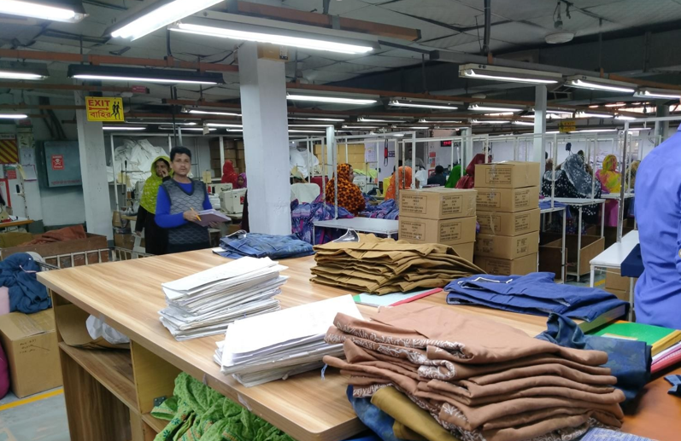

**Images of Finishing Section**

**Chapter 4**

**Internship Experience**

An internship is a period of work experience offered by an organization for a limited period of time. It is a professional learning experience that offers meaningful, practical work related to a student's field of study or career interest. It can help bridge the gap between academia and a professional position. An internship can be paid or unpaid, and some programs may offer academic credit upon completion of the term. As a compulsory requirement of the internship course, I have done an industrial internship in Yellow by BEXIMCO, BEXIMCO INDUSTRIAL PARK. I have gained a lot of experience in work, workplace behavior, time management, etc. The knowledge that I gained from the internship however it’s quite different from academic knowledge.

**Interview Session**

On Saturday, May 13, 2023, BGMEA University of Fashion & Technology (BUFT) organized a job fair for their students to which Beximco by Yellow was invited. After getting encouragement from some of my honorable teachers at my university I attended the fair along with my CV & previous Academic work file. The fair started at 9 a.m. and I saw many candidates waiting. At  10 am I was called for the interview. They asked me several questions and I tried to give all the answers politely. The interviewers also asked me to design a casual outfit. For designing they give me 20 minutes. I designed a simple but comfortable casual outfit for women and submitted it to them within time. After completing my interview I came out from the interview room. As rules I gave my contact information & one copy of my CV to Afroza Akter Rita ma'am. That's how my interview journey ends. I learned lots of things through this interview.

**Position, Duties & Responsibilities**

Position, Duties & Responsibilities three word plays an essential role in the job sector. The duties and responsibilities of a job are the tasks an employee in that position should complete regularly. When I define the duties and responsibilities of a job, I am effectively defining its role in the business.

I started my internship period experience from the confirmation call because Beximco by Yellow has been very careful from that day. My position was intern as a designer and my target in the internship period was learning. My work starts from 10.30 am to 6.00 pm. I am successful in my mission, I learned different things through this period. My duties were to follow my seniors and work according to their instructions. My responsibility was to carry out the instructions without any mess. Because I know, that if I don't work according to their instructions it will waste time & will increase the work pressure for them. In that case, as an intern, I will be a failure. So, I tried my best to give the best result of my work as they expected from me.

**Work Samples During Internship**

In my internship period I worked on lot of things. I designed several motifs, manual and digital outfits. I also researched on products. Now I will briefly discuss about some of my works during my internship.

As I was in designing section, I designed several Panjabis and their motifs. To increase my thoughts and create new looks I did some research on Panjabi. After research, I made a PowerPoint presentation so that all the information could be in one place.

* ***Panjabi The Ethnic***

The Panjabi is a long loose piece of rectangular clothing sewn together, keeping an open end on the front and one below the neck region. It has open slits on both sides of the dress, and the dress flows up to the knee region, sometimes even more. Panjabi is the most widely accepted traditional dress in Bangladesh for men.

Normally, the wearing the panjabi is saved for prestigious occasions. And so, Bangladeshi men wear panjabi on various occasions such as - wedding ceremonies, formal parties, religious festivals, etc. All these applications make it even more clear about the nationwide acceptance and preference of panjabi among Bangladeshi males, not to mention its versatile usage as well. panjabis are created out of different kinds of materials like - cotton, Rajshahi silk, Katan, Jamdani etc.

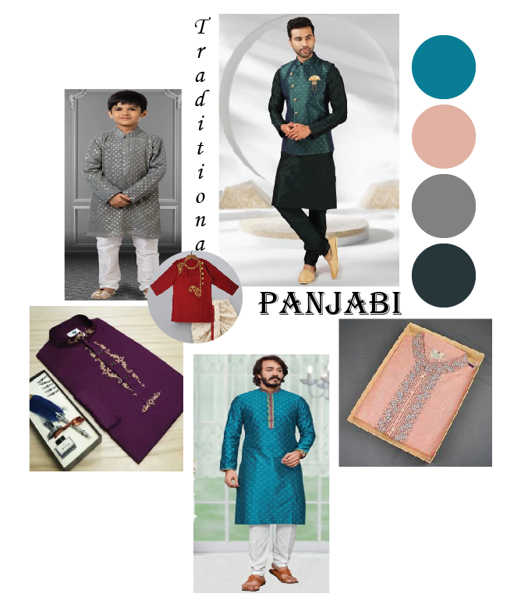

**Panjabi the Ethnic wear for Men**

* **History**

The Bangladeshi people wholeheartedly accepted panjabi as their official traditional dress during the Sultani Era. There is a bit of controversy to this history because another source mentions that the origin of panjabi actually happened from the influence of the panjabi people.

The panjabi people, during the undivided Bengal, used to migrate to the current Bangladesh region by waterways. Usually, businessmen came here to sell their products on a regular basis. Products like - male clothing, female clothing, jewelry, bedsheets, food items, etc. were sold regularly.

Even long before colonialism took place in this subcontinent, the Mughals, and subsequently the Nawabs created a diversity of business opportunities in Bengal. This created an opportunity for businessmen like the Punjabs to set a fashion standard that replaced the dress standard of the Bangladeshi people.

* **The Best Fabric for Panjabi**

Panjabi is a traditional garment worn by men in South Asia, particularly in Bangladesh and India. Several possibilities consider while deciding on the appropriate Panjabi fabric, according to desire and the occasion.

**The most popular fabrics for Panjabi are listed below:**

**Cotton:** Cotton is one of Panjabi’s most commonly used fabrics for its comfort, breathability, and durability. It is an excellent choice for everyday wear and can easily dye in different colors.

**Silk:** It is a luxurious material that adds elegance and sophistication to the Panjabi. It is famous for weddings and formal occasions due to its lustrous appearance and soft texture.

**Linen:** It is a lightweight and breathable fabric perfect for summer. It has a textured appearance and is less formal than silk, making it a good choice for casual events.

**Khadi:** Khadi is a hand-spun and handwoven fabric popular in India. It is made from cotton or silk and has a rough texture that adds a rustic charm to the Panjabi.

Ultimately, the fabric choice for Panjabi will depend on your preferences and the occasion. Cotton and silk are famous for comfort and elegance, while linen and khadi are great for casual settings.

* **Panjabi Fabric Design**

Many different designs and patterns are used in Panjabi fabric, each with its unique characteristics and appeal. Some of the most common methods and ways used in Panjabi cloth include the following:

**Floral:** Floral designs are popular for Panjabi fabric, particularly in women’s attire. They can range from delicate and intricate patterns to bold and vibrant designs and create using embroidery, printing, and applique techniques.

**Geometric:** Geometric designs are another common choice for Panjabi fabric, particularly in men’s attire. They can be simple and understated, bold and complex, and can create using various techniques such as weaving, embroidery, and printing.

**Paisley:** Paisley is a popular design element in traditional Panjabi attire and often use in men’s and women’s clothing. It characterizes by its curved and teardrop-shaped motifs, which can be simple or elaborate and can create using various techniques such as weaving, printing, and embroidery.

**Abstract:** Abstract designs are a more modern and contemporary option for Panjabi fabric and can include a range of styles and patterns, such as stripes, dots, and swirls. They can create using various techniques such as printing, embroidery, and applique.

Animal designs are popular for Panjabi fabric, particularly in women’s attire. They can use various techniques, including embroidery, printing, and applique, and they can incorporate a variety of motifs, including birds, elephants, and peacocks.

Overall, many designs and patterns can be used in Panjabi fabric, each with a unique style and appeal. The design choice will depend on personal preference, the desired style and look, and the occasion.

* **Panjabi Fabric Market in Bangladesh**

Panjabi fabric is an essential product in the textile industry of Bangladesh. The country has a thriving market for Panjabi fabric domestically and internationally. Here are some critical facts about the Panjabi fabric market in Bangladesh:

**Production:** Bangladesh is a significant producer of Panjabi fabric, with many textile mills and factories dedicated to its production. The country produces various materials, including cotton, silk, and synthetic blends.

**Export:** Panjabi fabric is one of the major textile products exported by Bangladesh. The country exports Panjabi fabric to several countries.

**Design:** Bangladesh has a rich textile design tradition, reflected in the procedures used in Panjabi fabric. The fabric can find in various methods, including floral, geometric, paisley, and abstract patterns.

**Price:** Depending on the fabric’s quality, the type of fiber used, and the complexity of the pattern, Panjabi fabric prices in Bangladesh might vary significantly. Cotton Panjabi fabric is generally more affordable than silk or synthetic blends.

**Marketplaces:** The major marketplaces for Panjabi fabric in Bangladesh include Dhaka, Chittagong, and Narayanganj. These cities have a large number of textile mills, factories, and markets dedicated to the production and sale of Panjabi fabric.

Overall, the Panjabi fabric market in Bangladesh is an essential part of the country’s textile industry. Thanks to its long textile traditions and premium goods, the nation is a globally renowned manufacturer and exporter of Panjabi cloth.

* **Popular Brands in the India & Pakistan**
* Ismail Farid
* Fabindia
* Edenrobe
* Junaid Jamshed
* Gul Ahmed
* Manyavar
* Benstoke
* Twist
* Sojanya
* **Popular Brands in Bangladesh**

we will explore some of the best Punjabi brands in Bangladesh.

* Sailor
* ILLIYEEN
* Aarong
* Le Reve
* Yellow
* Brand Hook
* Cats Eye
* Kay Kraft
* Rang
* Dorji Bari
* **Types of Panjabi:**

There are various types and styles of Panjabi. There are:

* Straight Cut
* Churidar
* Jacket Style
* Indo Western
* Asymmetric,
* Front Slit, Side Slit,
* A line,
* Fancy,
* Floral,
* Chanderi,
* Jodhpuri,
* Calf length etc

I had to design on Stright Cut style for the Panjabi. So, I have done detailed research.

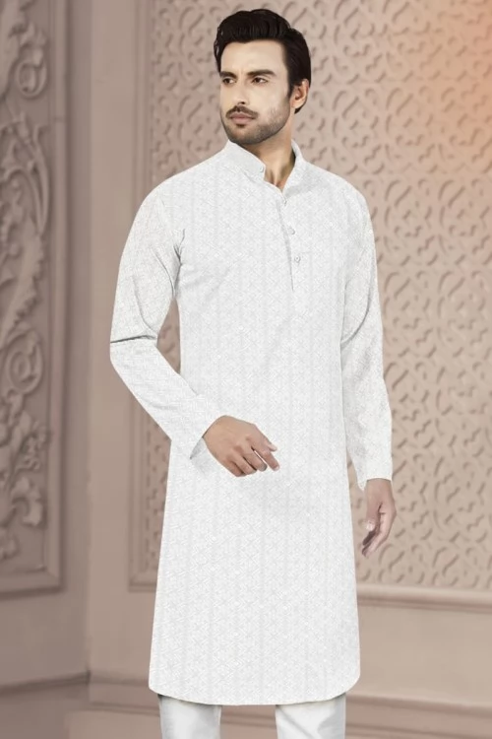

Straight Cut

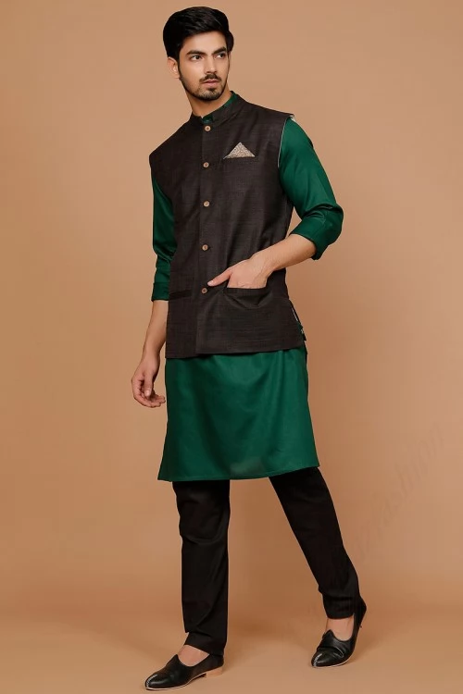

Jacket Style

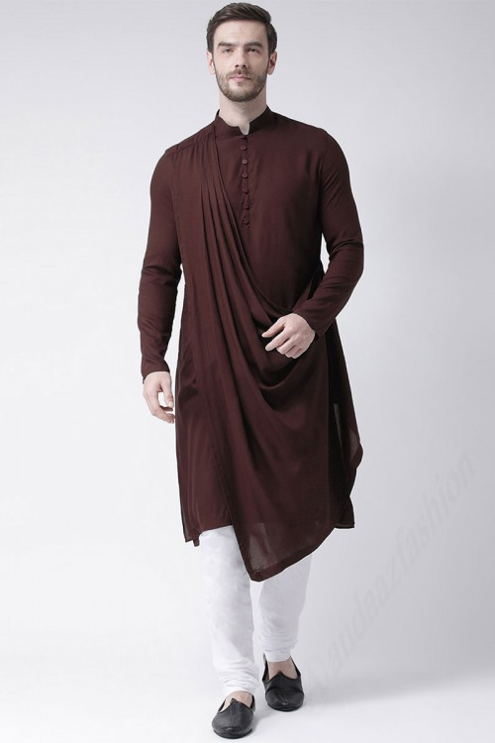

Indo Western

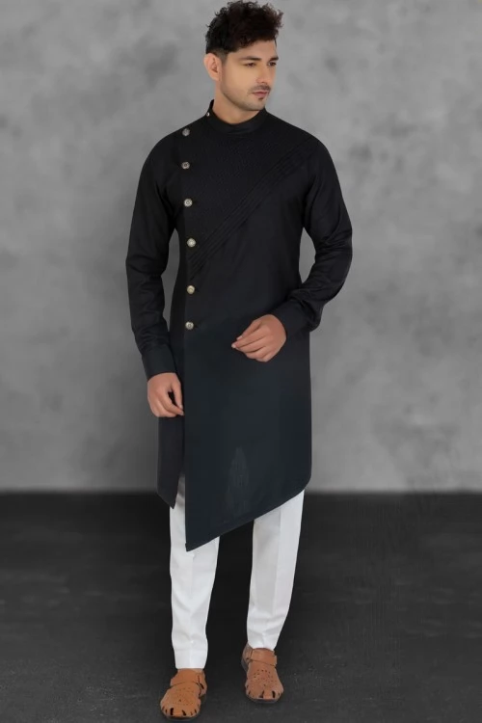

Asymmetric

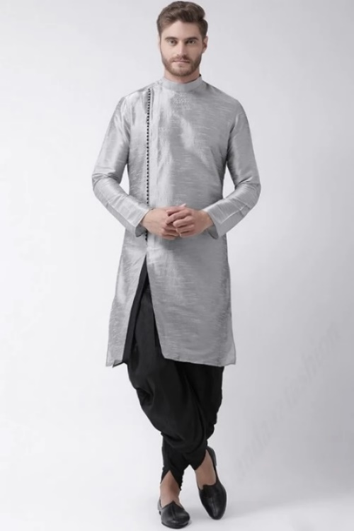

Side slit

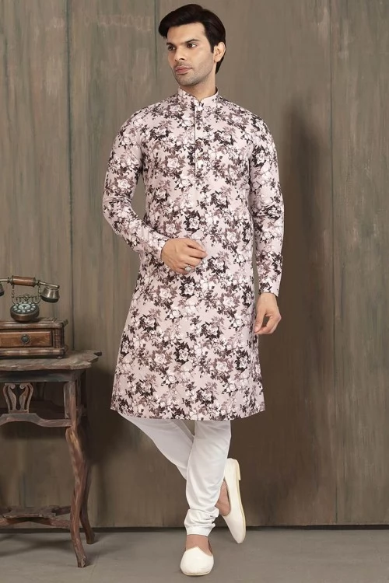

Floral

* **Stright Cut Style**

It is the style where the pieces of panjabi are cut totally straight without any variation. The timeless design of a straight-cut panjabi is quite outstanding in terms of elegance and class, regardless of being simple. The most common panjabi of all time. Though for cut & sew it maintain the basic cut and sewing process but now this style can be amazing by giving different types of prints, embroidery design or zardozi work. Generally, It’s measurement chose three types of fit.

There are –

* Regular Fit
* Slim Fit
* Casual Fit.

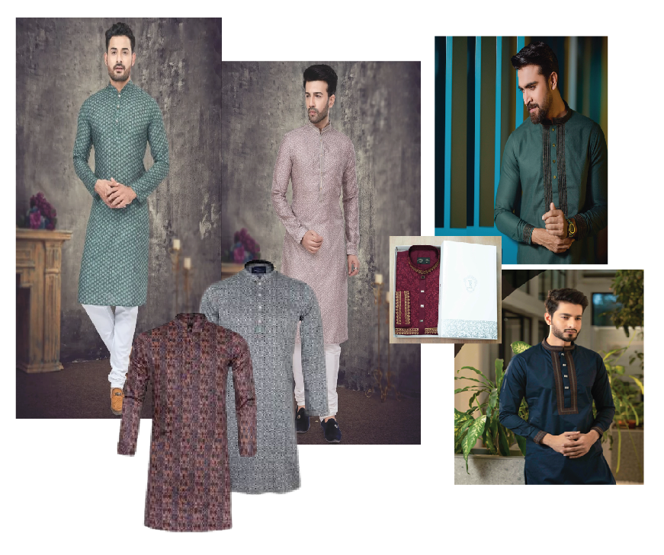

**Images of Straight Cut Style**

* **Sample for Production**

I was instructed to make a Panjabi for a sample production. After hearing all the instruction carefully I made a flat sketch and simply write down all the steps that I had to do.

To make sample for production at first, I designed the embroidery of the collar and placket of this Panjabi. The embroidery design was done manually. Then I chose the fabric and went to the embroidery section where I have done the hand embroidery on the chosen fabric. After that, I went to the next process which was cutting section. I instructed them to cut the fabric with the given measurement. For the next step, I went to the sewing section and instructed them to sew all the cutting parts. Finally, I was able to made a "M" size sample Panjabi for the production.

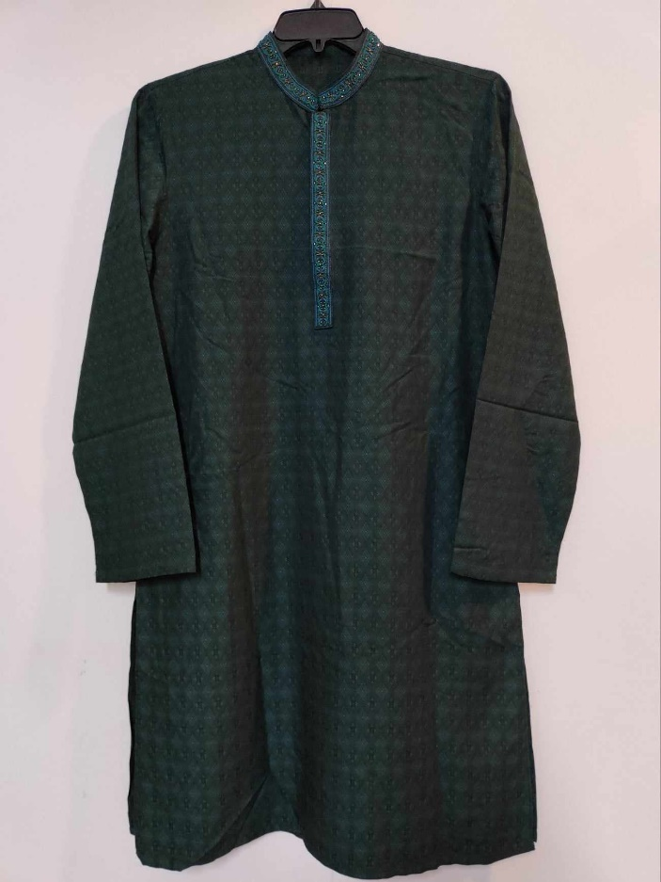

**Images of Sample Panjabi for Production**

**Some Requisition Form Sample**

* **Tech Pack Sample**

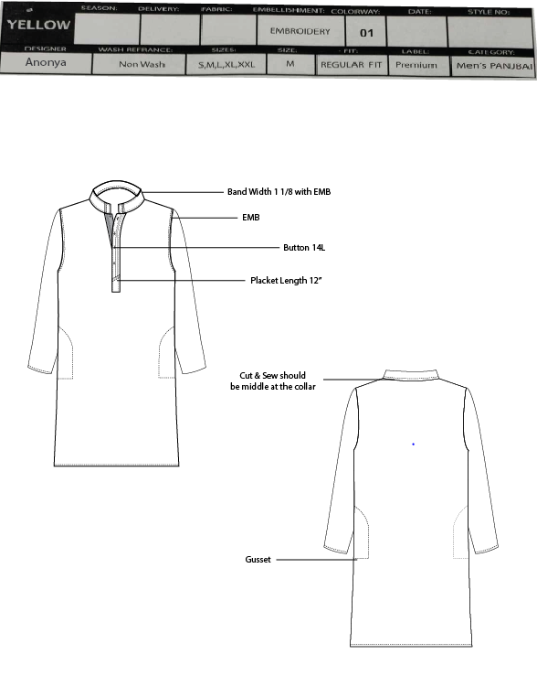

* **Patter Order Request Sample**

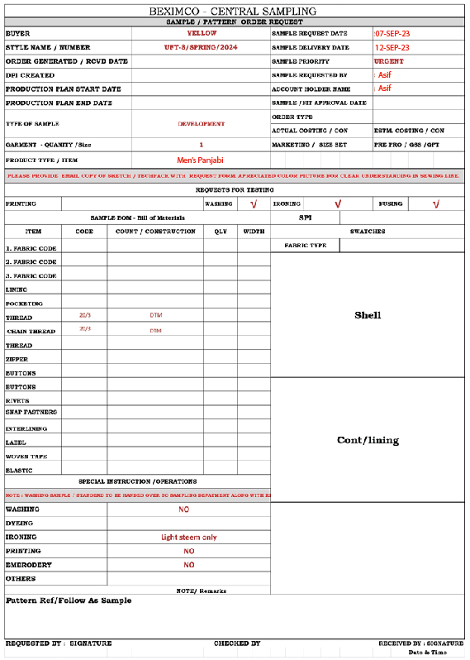

* **Print & Graphics Sample**

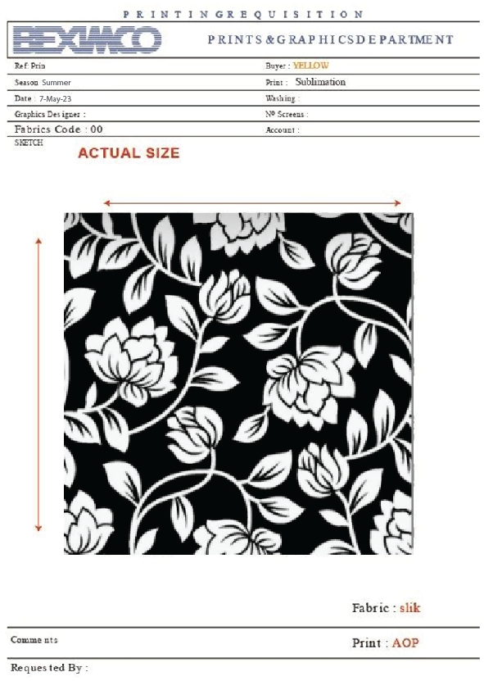

**Digital**

* **Print & Graphics Sample**

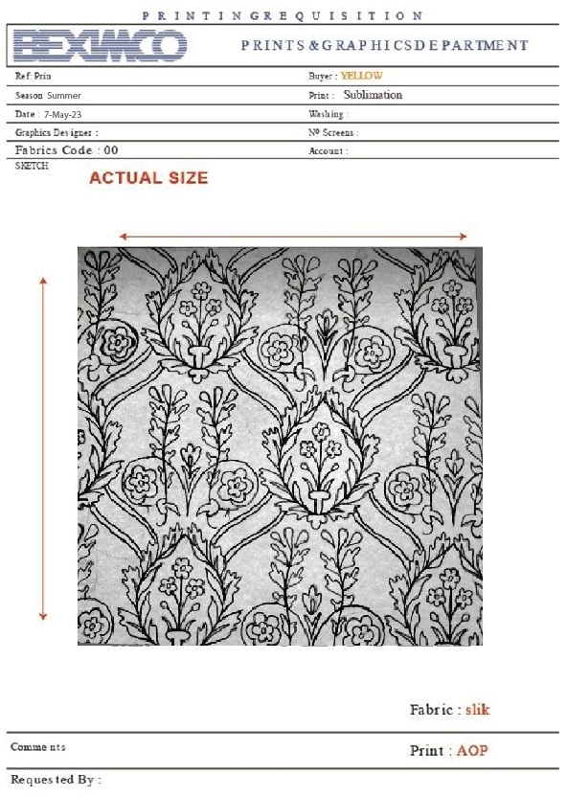

**Manual**

* **Some of my manual work**

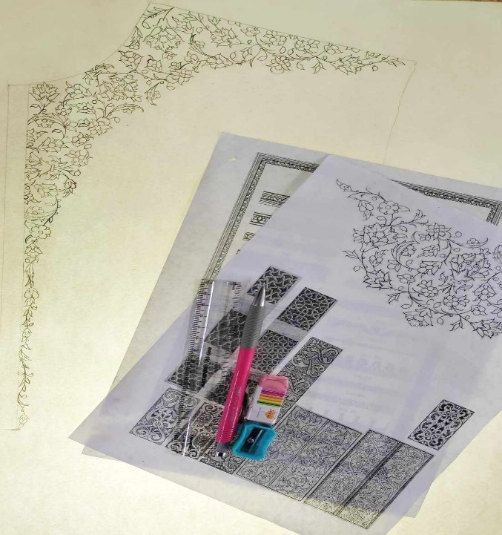

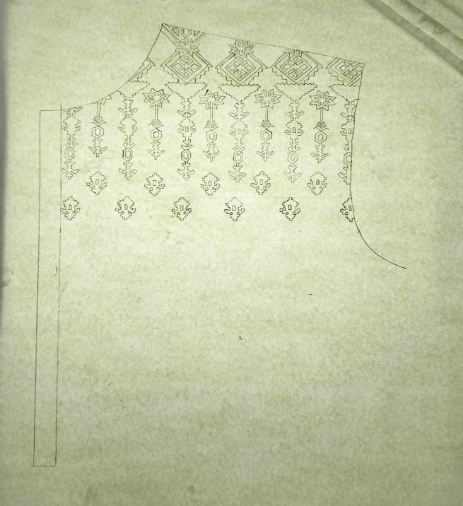

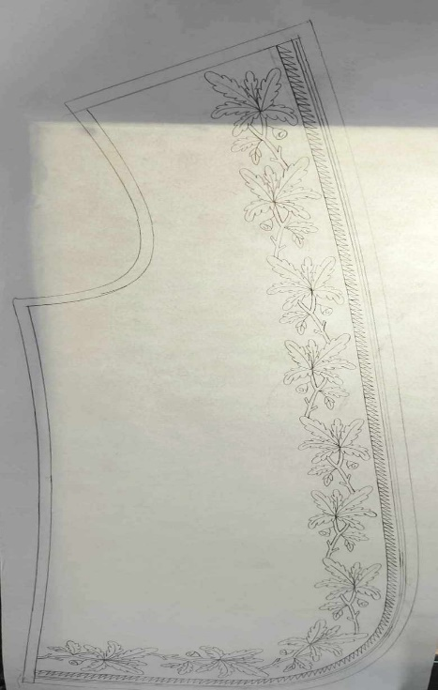

* **Some Mockup Sample Making During Internship:**

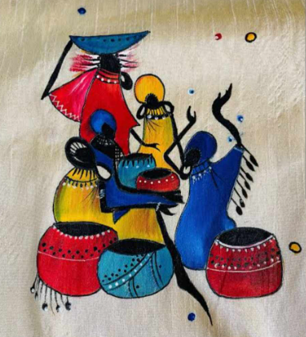

**Hand print**

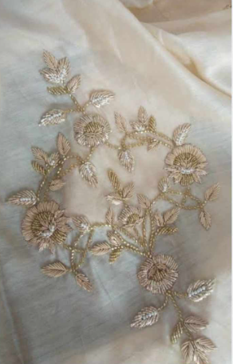

**Karchupi**

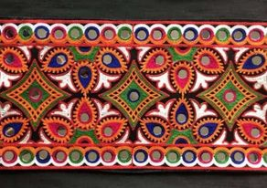

**Kutchi**

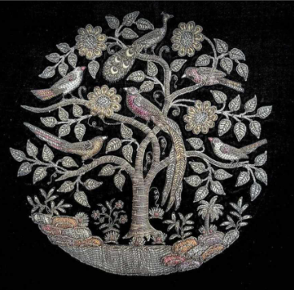

**Zardosi**

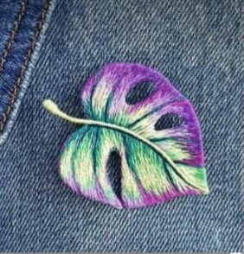

**Embroidery patch**

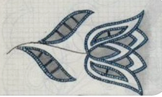

**Laser cut embroidery**

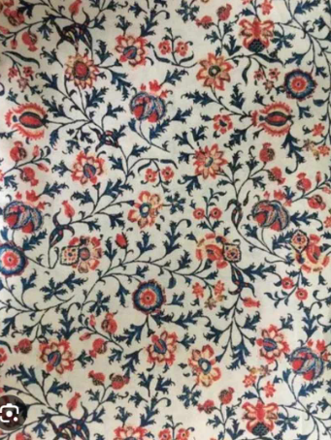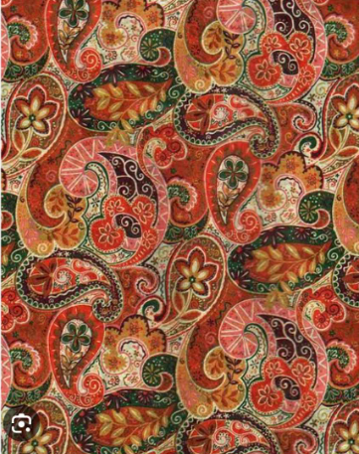

**Digital print**

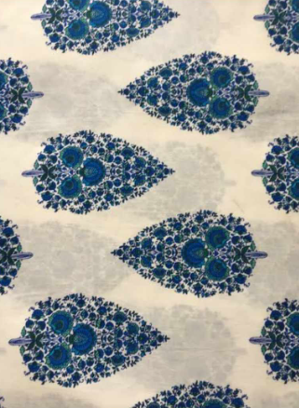

**Screen print**

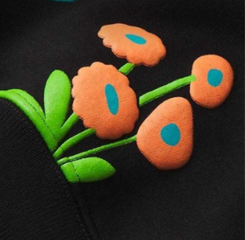

**Puff Print**

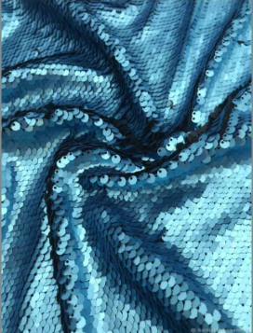

**Sequin Fabric**

**Overall Analysis of Internship**

From my information call to my last day, Beximco by Yellow is very careful with their interns. Before joining the day, they called me several times If I was joining or not, and also asked me if I had any issues that needed to be solved. They try to help their interns a lot because most interns are final-year students or fresh graduates. Many times, they don’t understand many things. So, they teach each and every little thing to us. I learned from this, how they motivate their interns. They believe in employee satisfaction. Their human resource department is so strong, they always think about employee satisfaction. In my working days, I learned how to talk with people professionally. My communication skills increased through talking to different people. Now I can work under pressure. Learned, how to design professional and industrial way. How to create the outfits step by step from first to last. Also, I got to know that a teamwork environment is totally different than working alone. It helps to create a bond among the employees. Helped each other to learn new things. Learned how to analyze market demand to create new collections using different websites.

In short, I can say I had a good experience and confidence after this internship. The work procedure was so much interesting.

**Chapter 5**

**Recommendation & Conclusion**

* **Recommendation**

BEXIMCO Apparels Ltd is the largest textile group in Bangladesh. It has outstanding reputation in the global market for excellence. In contrast to that, Yellow is an international brand now. And has plans to not only go global, but also to become well known all across the globe. The Beximco Textile from which Yellow works it production, is a composite factory where they have all the sectors of woven and knit item like spinning, knitting, dyeing, printing, embroidery, accessories, and garments production. So, this is huge in case of production and maintenance both.

However, this huge organization is facing difficulty in gathering the maximum profit due to many of reasons what I have observed from the internship period Supply chain or procurement department is not very strong in this company which causes that the merchandisers procure all the raw materials of garments that’s why they feel more pressure to complete shipment and sometime also over the shipment date then company should pay the extra money for air shipment. So, when supply chain department procure all the raw materials then merchandiser can easily shipment the goods within lead time,

1. Planning department of operation should be strong and the time management should be followed. Here, productivity is low due to less command of the authority towards the production. It should be increased for the higher productivity.

2. Quality assurance system should be modernized because quality is the top priority of all international buyers.

3. Pay scale is very poor which is needed to be increased because company will lose potential employees due to their policy.

4. Distribution of power should be well managed and transparency among the workers and the management should be followed.

The organization is one of the biggest organizations in Bangladesh and contributing the highest Amount of GDP in the economy but if it follows these areas then it will be among the greatest in the region.

* **Conclusion**

In conclusion, I can state that this internship report is highly important for any fashion design student to complete in order to get knowledge of the textile sector. I have a general understanding of the RMG sector, and it may be useful to learn about the technical and administrative expertise of the apparel industry as well as these companies that are associated to the sector. There is still much to learn about this vast industry. I want to thank my industrial supervisor for providing me with such a wonderful learning experience. I will benefit from this internship program as I face new obstacles in my life. I make an effort to provide this project with a diversity of papers linked to clothing. Being a part of the BEXIMCO group has been a great positive experience for me since everyone there is so helpful.

My overall experience was good I learned many things which will help my future work. I can show this four-months experience as an experience. It was a great achievement for a final year student.

**List of Abbreviations**

* CAD - Computer-Aided Design
* AOP – All Over Print

**References**

* Official Website of BGMEA University of Business & Technology
* Official Website of BEXIMCO
* Article of BEXIMCO – The Prothom Alo
* Official Website of Yellow
* Article of Yellow – The Daily Star
* About Industrial Garments Quara
* Textile Department in the Garments Industry Textile Learner
* Clothing Production Process Textile Learner
* Working Procedure in Garments Industry – Garments Merchandising
* Why Bangladeshi People Like Panjabi as Traditional Dress – Strides
* Panjabi Fabric in Bangladesh – Fabric Lagbe